Set A : User catalogue

Checking the server :

Get users:

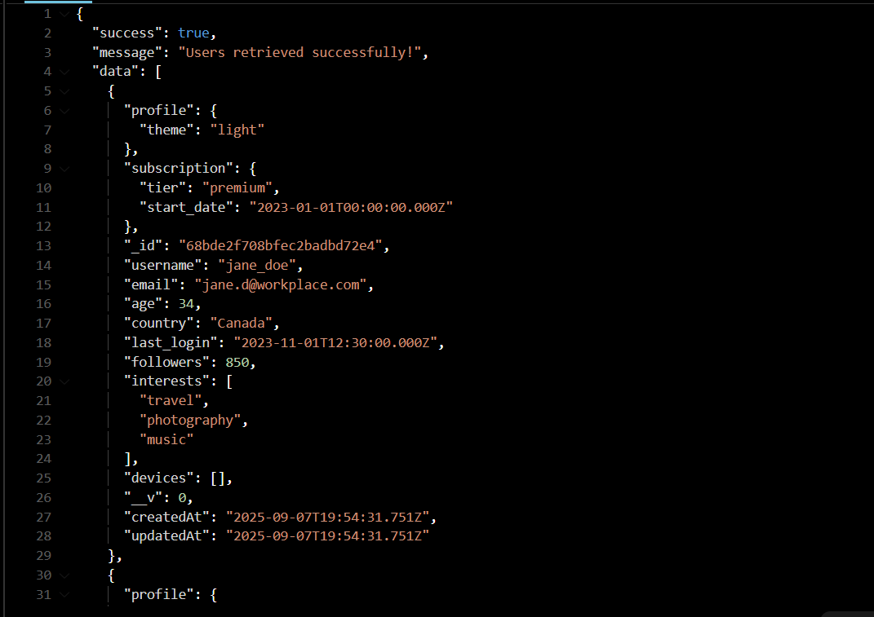

Get a specific users by id :

Creating the users:

Update the users :

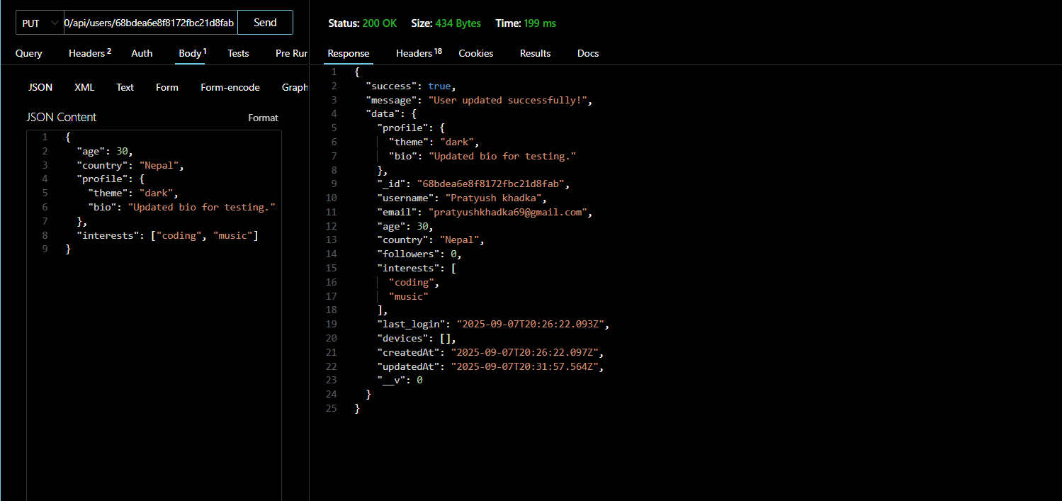

Delete the user :

Set B : Product catalogue

Getting all the products :

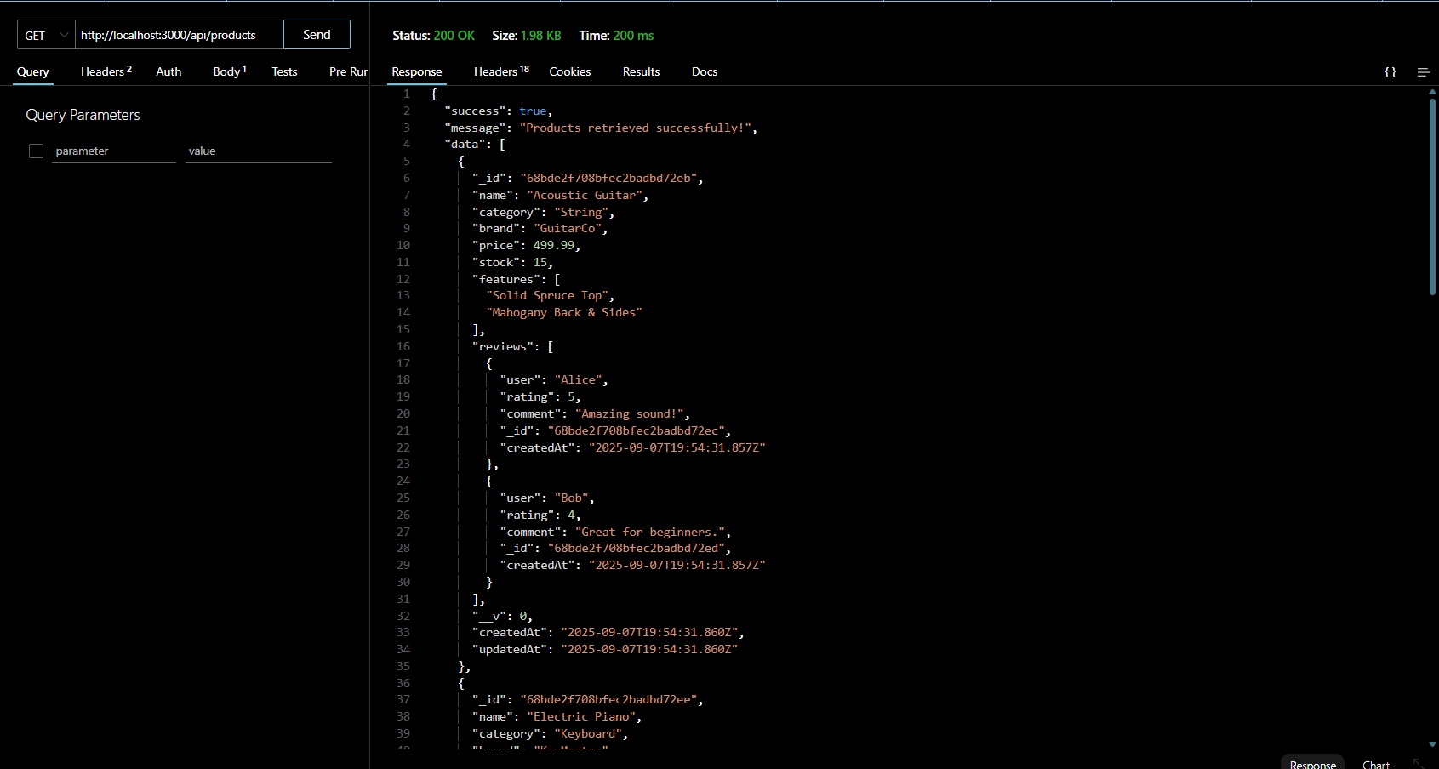

Create the product :

Adding review to the product :

Updating the product :

Deleting the product :

Updating the product :

Deleting the product :

Set c : Order catalogue

Getting the orders :

Creating the orders :

Getting all the order with status pending :

Getting the order details of specific users :

Updating the statuis of the order:

Set D : revenue Catalogue

Getting total revenue :

Getting Top selling products :

Getting reports by monthly salery :

